SINGLE AREA OSPF

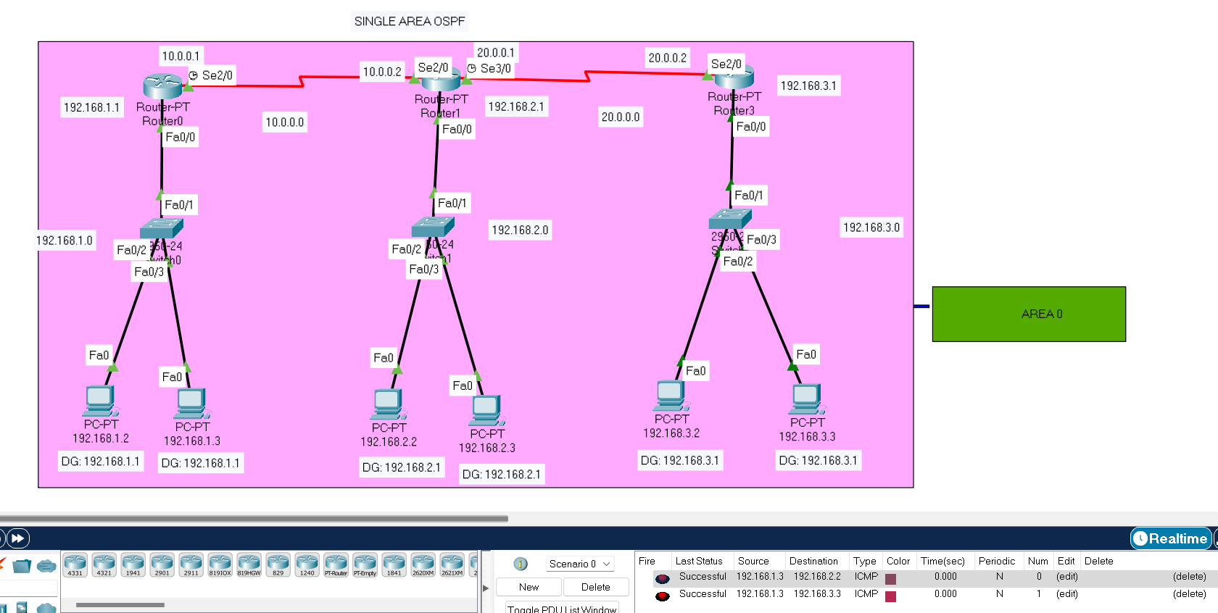

ROUTRER 0

Router#enable

Router#configure terminal

Enter configuration commands, one per line. End with CNTL/Z.

Router(config)#router ospf 1

Router(config-router)#network 192.168.1.0 0.0.0.255 area 0

Router(config-router)#network 10.0.0.0 0.255.255.255 area 0

Router(config-router)#end

ROUTRER 1

Router#enable

Router#configure terminal

Enter configuration commands, one per line. End with CNTL/Z.

Router(config)#router ospf 1

Router(config-router)#network 192.168.2.0 0.0.0.255 area 0

Router(config-router)#network 10.0.0.0 0.255.255.255 area 0

Router(config-router)#network 20.0.0.0 0.255.255.255 area 0

Router(config-router)#end

ROUTRER 3

Router#enable

Router#configure terminal

Enter configuration commands, one per line. End with CNTL/Z.

Router(config)#router ospf 1

Router(config-router)#network 192.168.3.0 0.0.0.255 area 0

Router(config-router)#network 20.0.0.0 0.255.255.255 area 0

Router(config-router)#end